**EDIT LEVELS OF PARTS LIST**

* **Right-click upper left-hand corner of Parts List / Edit Levels**

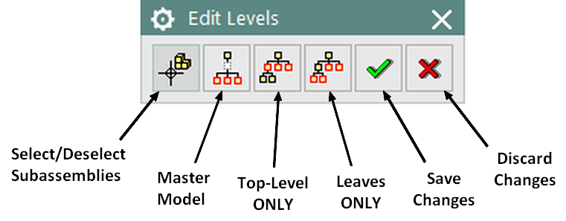

* **Use CTRL-click during selection/deselection in Assembly Navigator.**
* ***Note: Behavior of edit levels settings is complex. Experimentation is recommended.***

***Some relevant terms:***

***Part*** or ***Part File*** – Any file containing a solid model or models (the “part” could be an assembly, subassembly, or individual component). Technically the drawing file is also a “part” in NX’s assembly structure, *but for clarity I will specifically refer to the drawing as “drawing” or “drawing part.”*

***Master Model*** – The main part that the drawing is based on.

***Parent*** – Any part file that functions as an assembly or subassembly (contains other parts as components [decendants]). Note: A parent part can also be a child of another part in the same assembly tree.

***Child*** / ***Descendant***– Any part file that is a component or sub-component of another part file. Note: A child part can also be a parent of other parts in the same assembly tree.

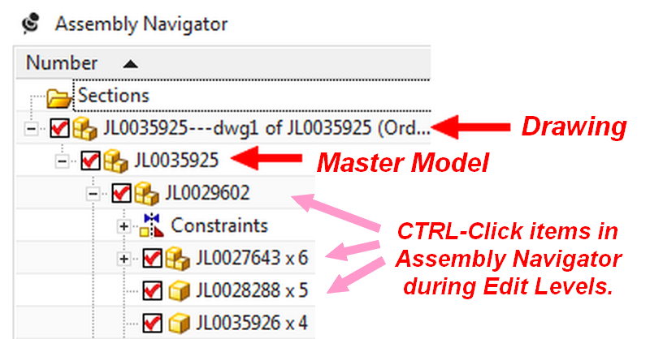

**Edit Levels Filter Buttons *(OFF by default****,**per our ‘Customer Defaults’ settings****).****Note: Toggling a button* ***ON*** *makes it turn slightly* ***darker gray****.*

 **Select/Deselect Subassemblies**

* **OFF:** Select/deselect clicked part only (no child components).
* **Toggled ON:** Allows selection of part clicked plus any children *(NOTE: Other filters determine whether parent or child components will be included in selection).*

 **Master Model**

* **OFF:** ***Includes*** the Master Model’s part number in the Parts List by default; it is shown as selected (highlighted) in the Assembly Navigator tree.
* **Toggled ON:** ***Removes*** the Master Model’s part number from the Parts List, deselecting it in the Assembly Navigator.

 **Top-Level only**

* **OFF:** All part levels included in Parts List by default. When selecting items by clicking in the Assembly Navigator, it allows selection/deselection of clicked part plus ALL active descendants (active = not suppressed). *(NOTE: Select/Deselect Subassemblies must be toggled ON during selection.)*
* **Toggled ON *and* *Master Model button OFF*:** Displays ONLY the Master Model Part in the Parts List. When selecting items by clicking, it allows selection of the part clicked ONLY.
* **Toggled ON *and* *Master Model button ON***: Displays ONLY the immediate children of the drawing part in the Parts List (but no descendants of the children). When selecting items by clicking, it allows selection of the part clicked ONLY.
* **Grayed out completely** (this occurs when ‘Leaves Only’ is toggled on).

 **Leaves Only**

* **OFF:** Other filters determine what is selectable.
* **Toggled ON:** Only children and/or descendants of parts will remain displayed in the Parts List and selected in the Navigator *[any parts that have children of their own are excluded from selection].*  When selecting items by clicking, only children and/or descendants of clicked part will be selected and displayed Navigator *[any parts that have children of their own are excluded from selection]*. *(NOTE 1: Select/Deselect Subassemblies must be toggled ON during selection. NOTE 2: The clicked part may appear highlighted, but is NOT INCLUDED in the Parts List.)* ***This behavior is difficult to describe fully; please try it out!***

 **Save Changes**

 **Discard Changes**